**SRS FOR FOOD DELIVERY WEBSITE AND APPLICATION**

**1  Introduction**

**1.1 Purpose**

The Food Delivery Website and Application (FDWA) is designed to provide a convenient and user-friendly platform for customers to order food from a variety of restaurants and have it delivered to their location. This document outlines the functional and non-functional requirements of the FDWA to ensure it meets the needs of customers and aligns with the goals of the business.

**1.2 Document Convention**

- The entire document should be justified.  
- Main Title: Times New Roman Bold 14.  
- Subtitle: Times New Roman Bold 12.  
- Body: Times New Roman 12.

**1.3 Scope of Development**

The scope of the FDWA project encompasses a comprehensive range of features and functionalities essential for creating a robust food delivery platform. This section defines the key aspects of the project's scope:

**1. User Registration and Authentication:**

-Customers can register and create accounts securely.  
   - User authentication is ensured through email verification and password protection.

**2. Restaurant Listings:**  
   - Display a list of restaurants, including their menus and ratings.  
   - Allow customers to search and filter restaurants by cuisine, location, and ratings.  
  
**3. Order Placement and Tracking:**  
   - Customers can browse menus, select items, and place orders.  
   - Real-time order tracking to monitor the status of the delivery.  
  
**4. Payment and Checkout:**  
   - Secure payment processing, including credit card and online payment options.  
   - Order confirmation and receipt generation.  
  
**5. Delivery Logistics:**  
   - Assign delivery personnel to orders.  
   - Optimize delivery routes for efficient and timely deliveries.  
  
**6. User Reviews and Ratings:**  
   - Allow customers to leave reviews and ratings for restaurants and delivery services.

**1.4 Definitions, Acronyms and abbreviations**

**Definitions:**  
  
- Customer: An individual who uses the FDWA to order food.  
- Restaurant Partner: An establishment that offers food through the FDWA.  
- Order: A customer's request for food items from a restaurant.  
- Delivery Personnel: Individuals responsible for delivering orders to customers.  
  
**Acronyms and Abbreviations:**  
- FDWA: Food Delivery Website and Application  
- UI: User Interface  
- UX: User Experience  
- API: Application Programming Interface  
- HTTPS: Hypertext Transfer Protocol Secure

**2. Overall Description**

**2.1 Product perspective**

**UseCase Diagram**

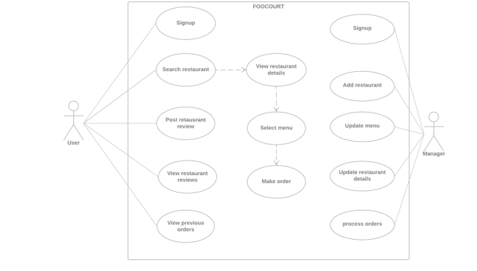

**2.2 Product function**

**System:**

Food Delivery Website and Application that allows users to order food from restaurants, track deliveries, and manage their orders.

**Actors:**

**Primary Actors**:

**Customer:** The primary actor who uses the food delivery website and app to order food.

**Restaurant**: The primary actor representing the restaurants that list their menu items on the platform.

**Delivery Driver:** The primary actor responsible for delivering orders to customers.

**Secondary Actors:**

**Customer Support:** Secondary actor providing customer assistance.

**Administrator:** Secondary actor responsible for managing the platform and resolving technical issues.

**Use Case Descriptions:**

**Customer Registration and Authentication:**

Primary Actor: Customer

Description: Customers register on the platform by providing personal details and authenticating their account. Once registered, they can log in to the system.

**Browsing and Ordering Food:**

Primary Actor: Customer

Description: Customers can browse restaurants, view menus, and place orders for food items. They can specify delivery preferences and make payments.

**Restaurant Management:**

Primary Actor: Restaurant

Description: Restaurants can manage their menu, update availability, and receive and fulfill customer orders.

**Delivery Dispatch:**

Primary Actor: Administrator

Description: The Administrator dispatches delivery drivers to pick up and deliver orders from restaurants to customers.

**Order Tracking:**

Primary Actor: Customer

Description: Customers can track the status and location of their food delivery in real-time.

**Customer Support:**

Primary Actor: Customer Support

Description: Customers can contact customer support for assistance with orders, refunds, or other inquiries.

**Technical Support:**

Primary Actor: Administrator

Description: The Administrator is responsible for resolving technical issues, ensuring the platform runs smoothly, and providing support to customers and restaurants when needed.

This use case diagram outlines the key interactions and functionalities of a food delivery website and application, involving various actors in the system.

**ER diagram**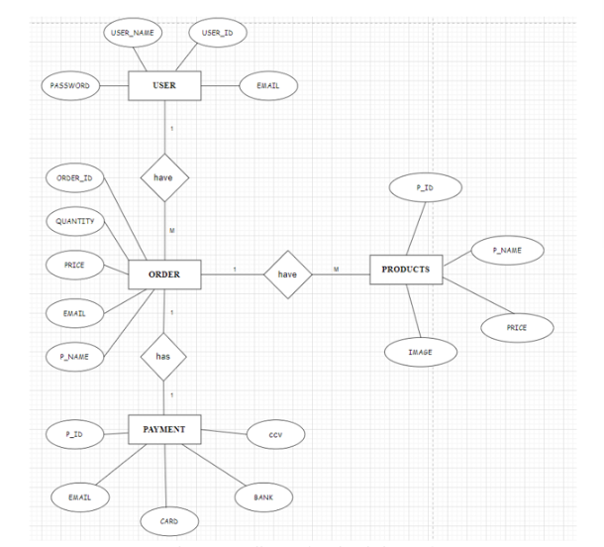

An Entity-Relationship (ER) diagram for a food delivery website and application would illustrate the essential data entities and their relationships within the system. It typically includes entities like "Customer," "Restaurant," "Order," and "Menu Items." Relationships would depict how customers place orders, how restaurants receive and fulfill those orders, and how delivery drivers are assigned. Attributes such as customer details, order status, and menu item information are associated with these entities. The ER diagram serves as a visual representation of the database structure, facilitating the efficient management of customer orders, restaurant menus, and delivery logistics in the food delivery ecosystem.

**2.3 User classes and characteristics**

- **Customer**: Primary users who order food through the platform.  
- **Restaurant:** Partner:Owners or managers of restaurants listed on the FDWA.  
- **Delivery Personnel**: Individuals responsible for delivering orders.

**2.4 Operating Environment**

The FDWA operates in a web and mobile application environment. Users require:  
- Internet access.  
- Web browsers (e.g., Chrome, Safari) for web access.  
- Mobile devices with Android or iOS for the mobile app.

**2.5 Assumptions and dependencies**

Users are assumed to have:  
- A stable internet connection.  
- Compatible hardware and software as specified in Section 2.6

**2.6  Requirements**

**Software Configurations:**  
- Backend server using Node.js.  
- Mobile app development using React Native.  
- Database management using MySQL.  
  
**Hardware Configurations:**  
- Processor Speed: 1.5 GHz or higher.  
- RAM: 2 GB or higher.  
- Mobile devices with at least 1 GB of RAM and 16 GB of storage.

**2.7 Data Requirement**

The FDWA requires access to restaurant menus, customer data, and delivery personnel information. Data synchronization between the platform and restaurant databases is essential.

**3.0  External interface requirements**

**3.1 GUI**

The graphical user interface (GUI) of a food delivery website and application plays a pivotal role in providing users with a seamless and engaging experience. It typically comprises several essential components:

1. **User Registration and Login:** Users can easily sign up by providing personal information and authenticate themselves with a username and password. The login screen ensures secure access to their accounts.

2. **Restaurant Listings**: The homepage features a user-friendly interface that showcases a list of available restaurants, complete with images, cuisine types, and ratings. Users can browse through these options to select their preferred dining choices.

3. **Menu Selection:** When users click on a restaurant, they are presented with a detailed menu, complete with descriptions, prices, and images of menu items. A simple ordering process allows users to add items to their cart.

4. **Order Tracking:** Users can track their orders in real-time, thanks to an interactive map or status updates. This feature enhances transparency and keeps customers informed about their order's progress.

5. **Payment Processing:** The GUI integrates secure payment options, including credit cards, digital wallets, and cash on delivery, ensuring a hassle-free checkout experience.

6. **User Profiles:** Users can access their profiles to manage personal information, view order history, and save favorite addresses for quick ordering.

7. **Customer Support:** An accessible customer support feature enables users to seek assistance, request refunds, or report issues directly through the app or website.

8. **Administrative Tools:** For restaurant owners and administrators, the GUI provides tools for managing restaurant listings, updating menus, and tracking orders in real-time.

Overall, an intuitive and visually appealing GUI enhances user satisfaction, making it easier for customers to explore restaurant options, place orders, and track their deliveries while providing restaurant owners and administrators with the tools they need to efficiently manage their operations.

**4.0 System features**

**4.1 User Registration and Authentication**  
  
- Users can register and log in securely.  
- Password reset functionality.  
- Email verification for new accounts.

**4.2 Restaurant Listings**  
  
- Display restaurant details, menus, and ratings.  
- Search and filter options for restaurant selection.  
  
**4.3 Order Placement and Tracking**  
  
- Browse menus, select items, and place orders.  
- Real-time order tracking with status updates.

**4.4 Payment and Checkout**  
  
- Secure payment processing.  
- Order confirmation and receipt generation.  
  
 **4.5 Delivery Logistics**  
  
- Assign delivery personnel to orders.  
- Optimize delivery routes.  
  
**4.6 User Reviews and Ratings**  
  
- Allow customers to leave reviews and ratings.  
- Aggregate and display restaurant ratings.

**5. Other Non-functional Requirements**

**5.1 Performance Requirement**

* Ensure fast response times for order placement and tracking.
* Handle peak order loads efficiently using load balancing.

**5.2 Safety Requirement**

* Implement data backups and disaster recovery plans.
* Secure customer payment information using encryption.

**5.3 Security Requirement**

* Secure database with access controls.
* Regularly update and patch the system for security.

**5.4 Requirement attributes**

* Define fee structures and payment processing rules.
* Ensure adherence to food safety regulations.
* Educate users about responsible ordering practices

**5.5 Business Rules**

* Customers should have an intuitive and responsive interface.
* Restaurant partners should be able to manage menus and orders efficiently.
* Delivery personnel should receive order details and optimize deliveries.

**5.6 User Requirement**

* Users include account holders, administrators, and customer support staff.
* Account holders should have a user-friendly interface for managing their accounts.
* Administrators should be equipped to manage user accounts and system maintenance.
* Customer support staff should have tools for assisting users and resolving issues.

**6 Other Requirements**

**6.1 Class Diagram:**

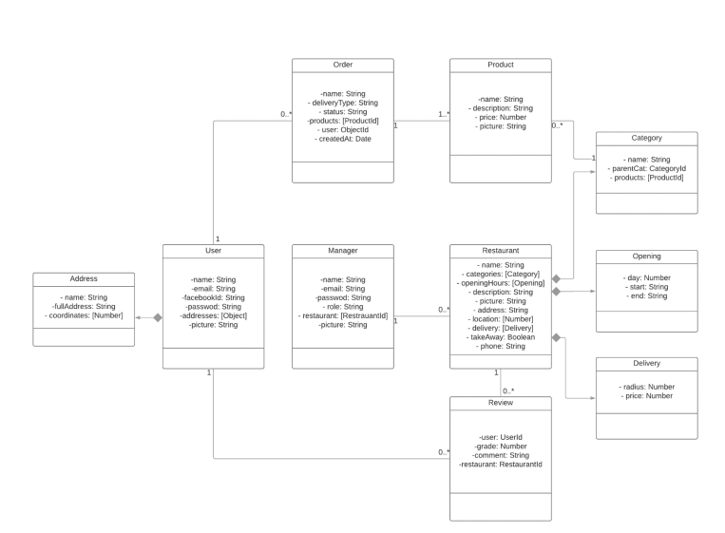

A class diagram for a food delivery website and application would serve as a visual representation of the system's object-oriented design. In this diagram, key classes like "Customer," "Restaurant," "Order," "Menu Item," "Delivery Driver," and "Administrator" are defined, each encapsulating specific attributes and methods relevant to their roles. Relationships between these classes depict how they interact within the system, such as customers placing orders, restaurants receiving and fulfilling orders, and drivers handling deliveries. This diagram acts as a blueprint for developers, guiding the creation of software that efficiently manages customer orders, restaurant menus, and delivery logistics in a structured and organized manner, ensuring the smooth operation of the food delivery ecosystem.